Install AppStarter and Kodi
Install AppStarter and Kodi in less than 5 minutes without anything else than the FireTV itself.

Short Version:
- Enable "ADB Debugging" and "Apps from Unknown Sources" in Developer Options
- Install "ES File Explorer" from Amazon App Store (search for "Es File")
- Add a Favorite in "ES File Explorer" which "Path" is set to http://fs.bpx.li and "Name" is set to fire
- Open the Favorite to download a .zip-file containing AppStarter
- Open the .zip-file and select the AppStarter APK file for installation
- Follow the installation routine and open AppStarter
- If you want also install Kodi, go to "Updates"-section in AppStarter and select "Update to latest Version" for Kodi
- Voila, both is installed :)

Long Version:

Go to Settings: 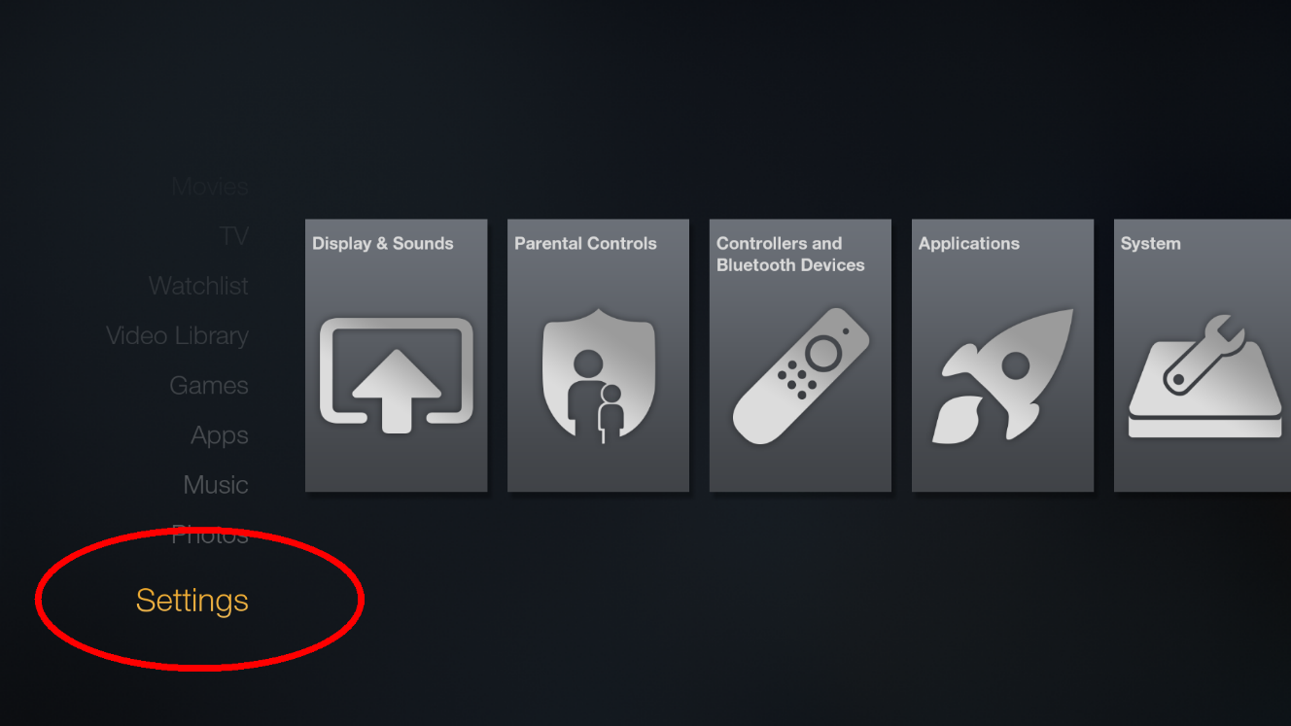
Go to Developer Options: 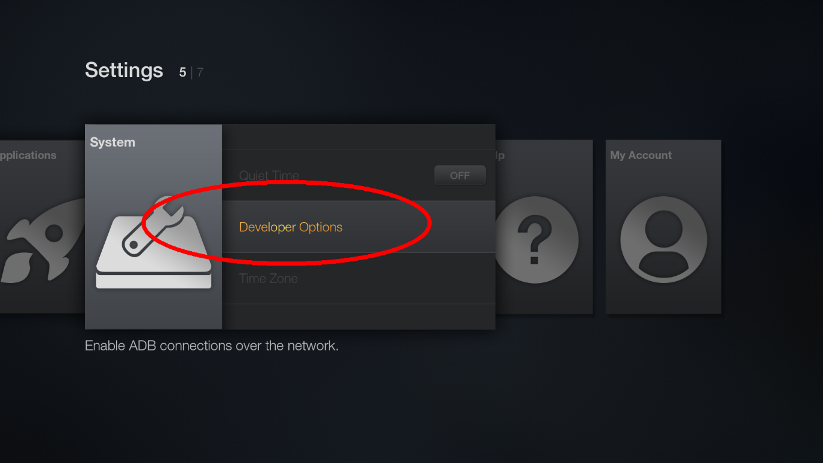
Enable "ADB Debugging" and "Apps from unknown sources" in developer options: 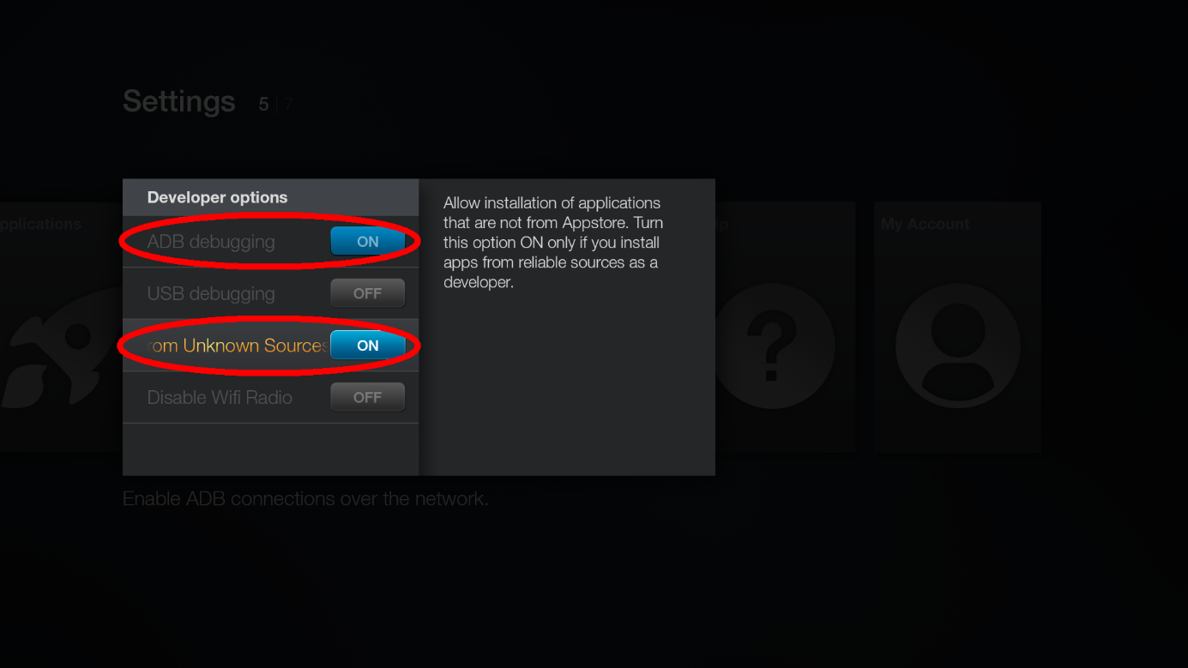
Go to Search 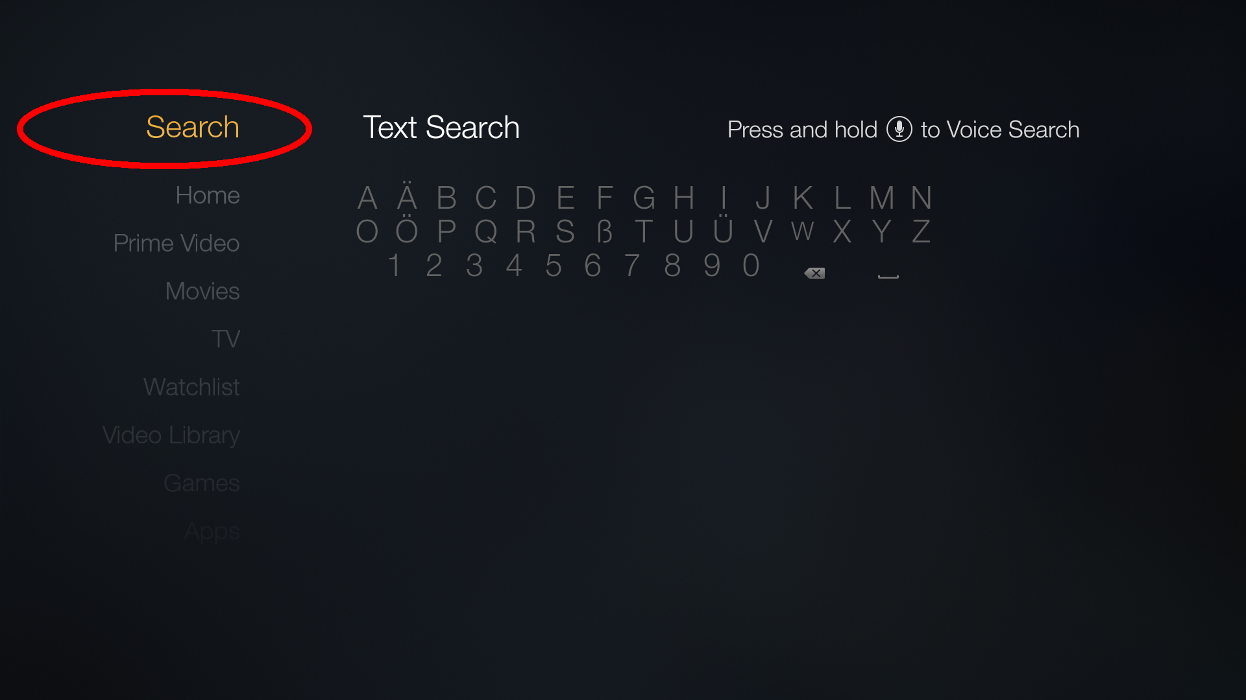
Type in Es File 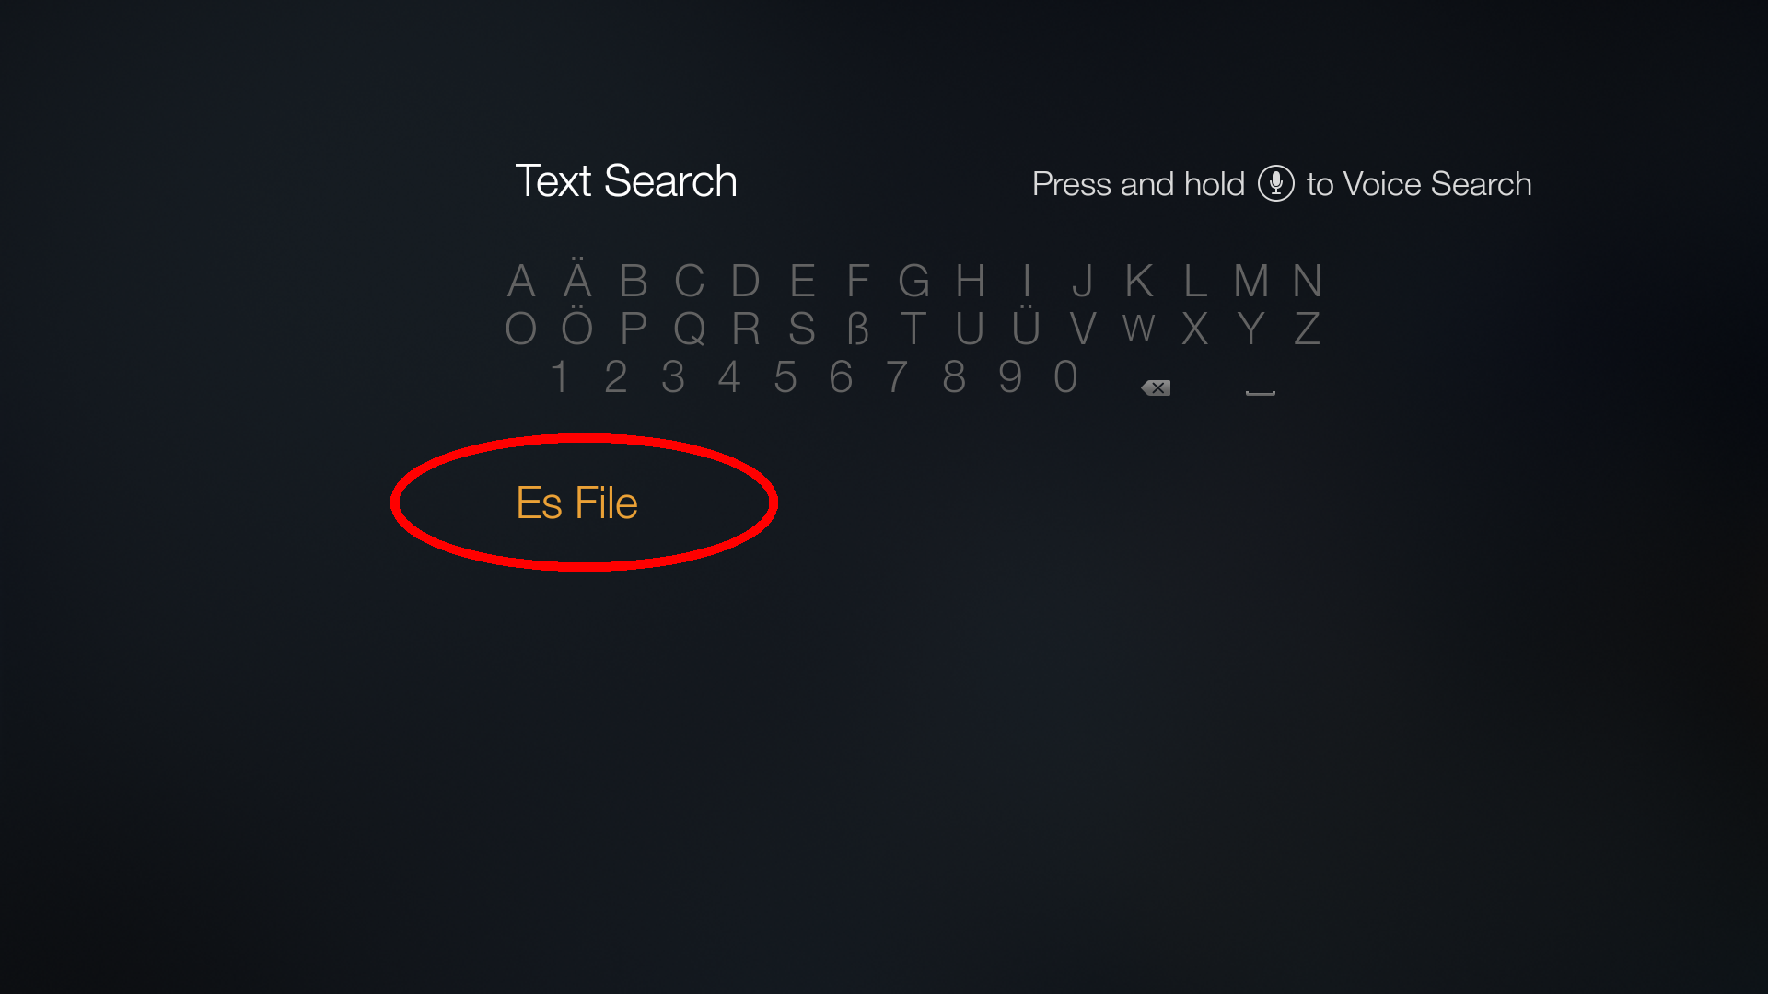
Change to Apps & Games 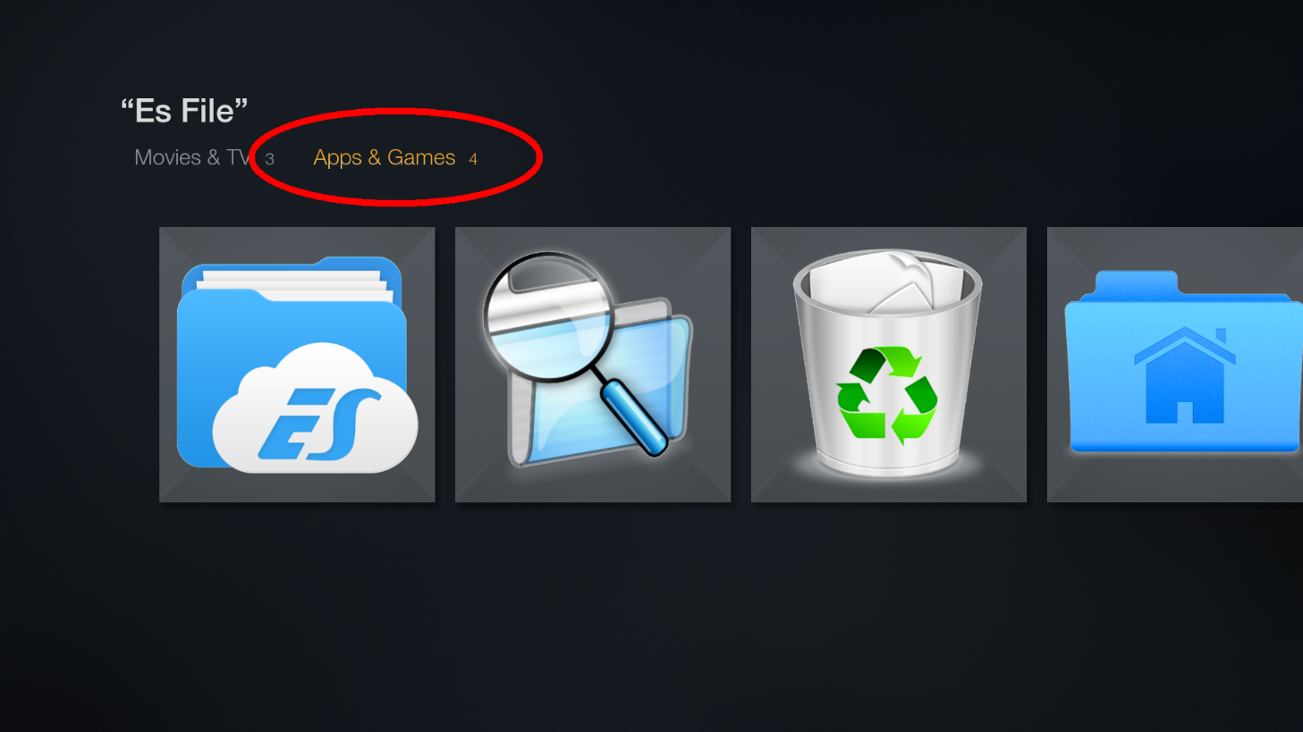
Select ES File Explorer 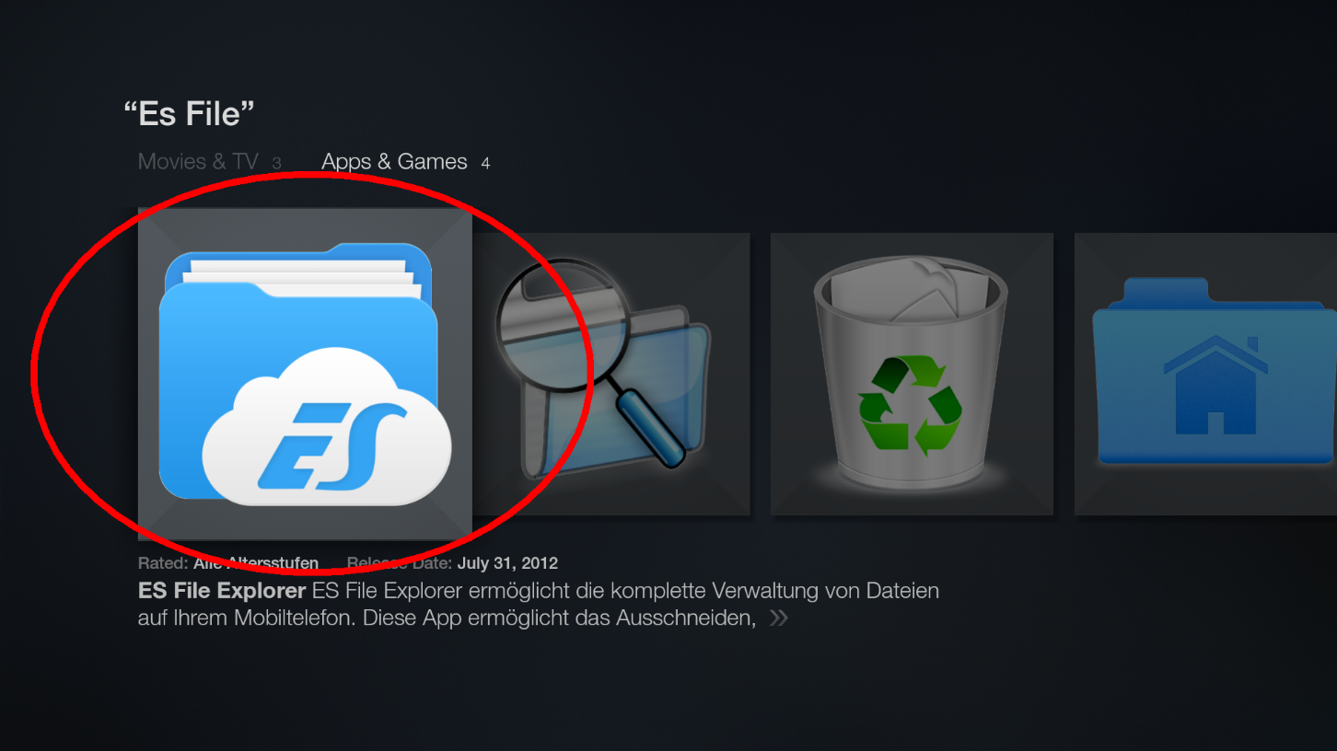
Download ES File Explorer 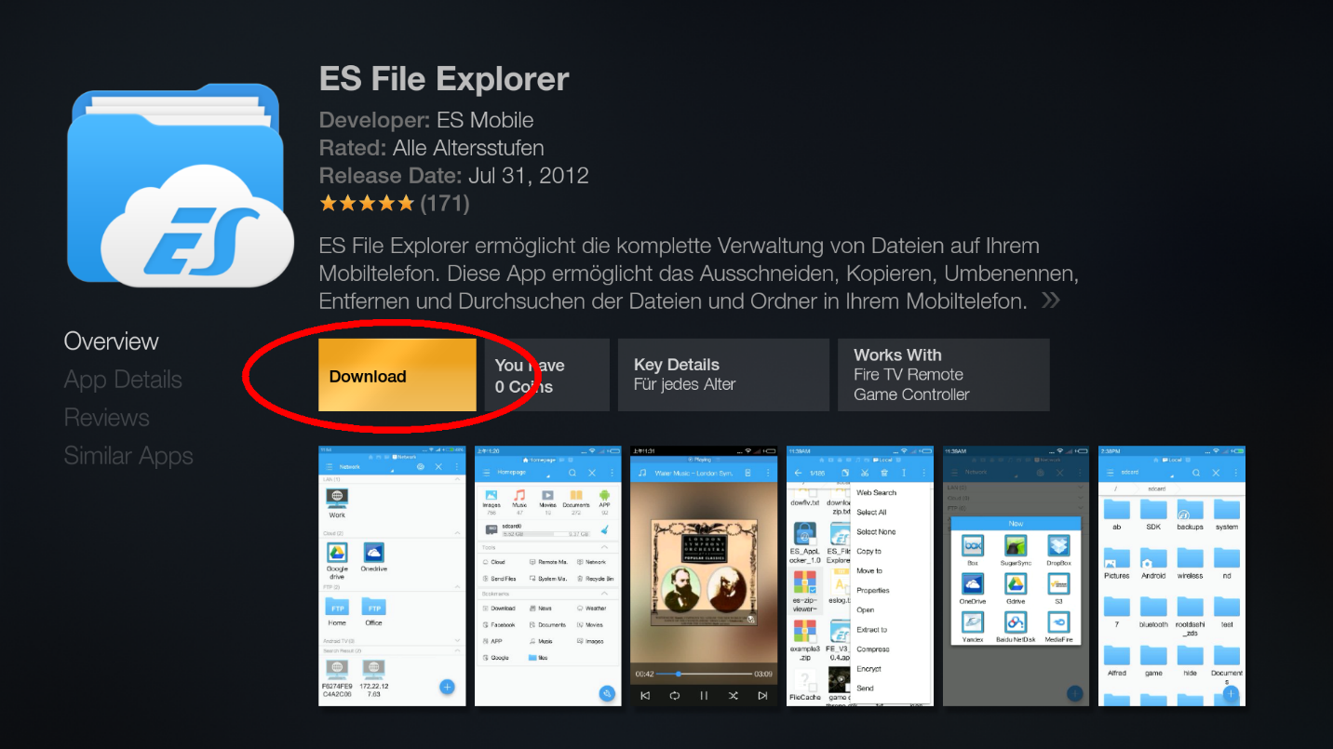
Open ES File Explorer 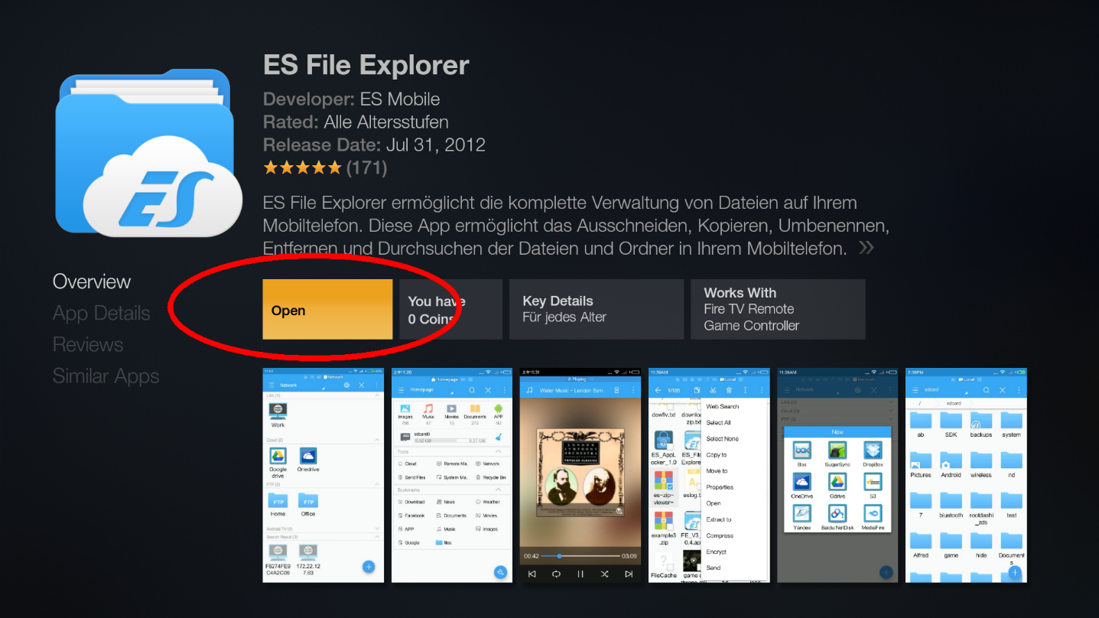
Cancel ES File Explorer update, as it does not work anyway.. 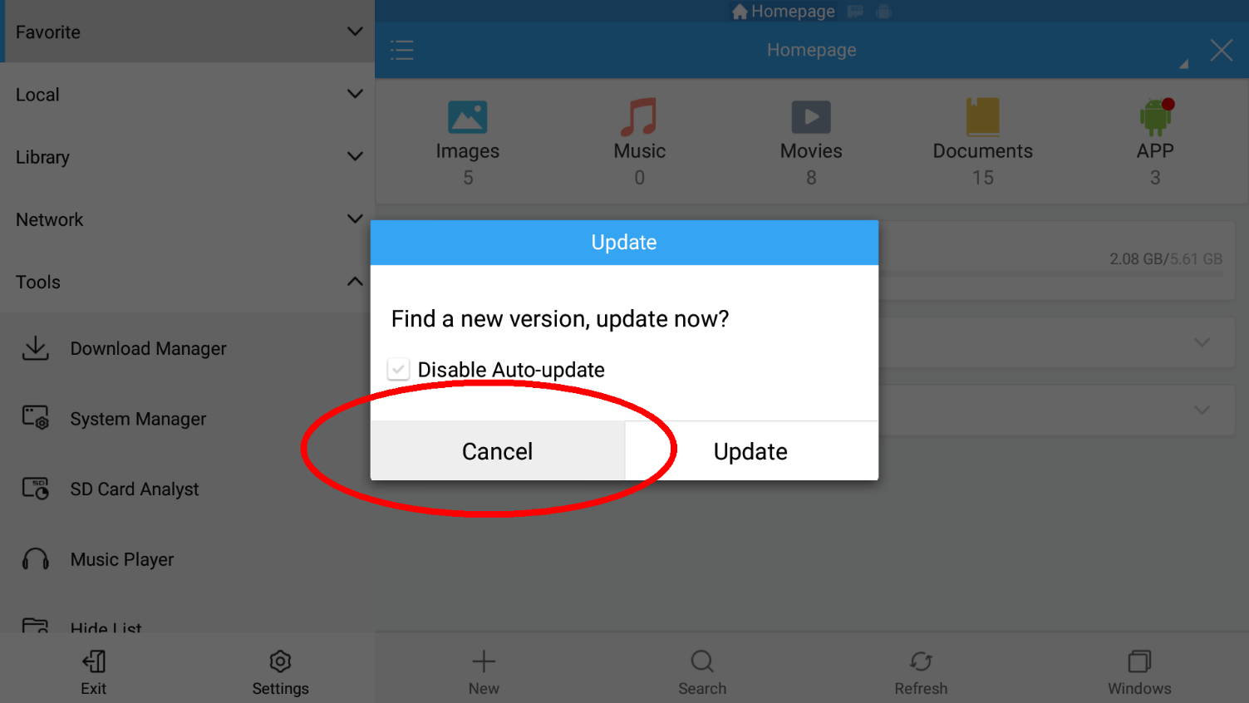
Select Favorite 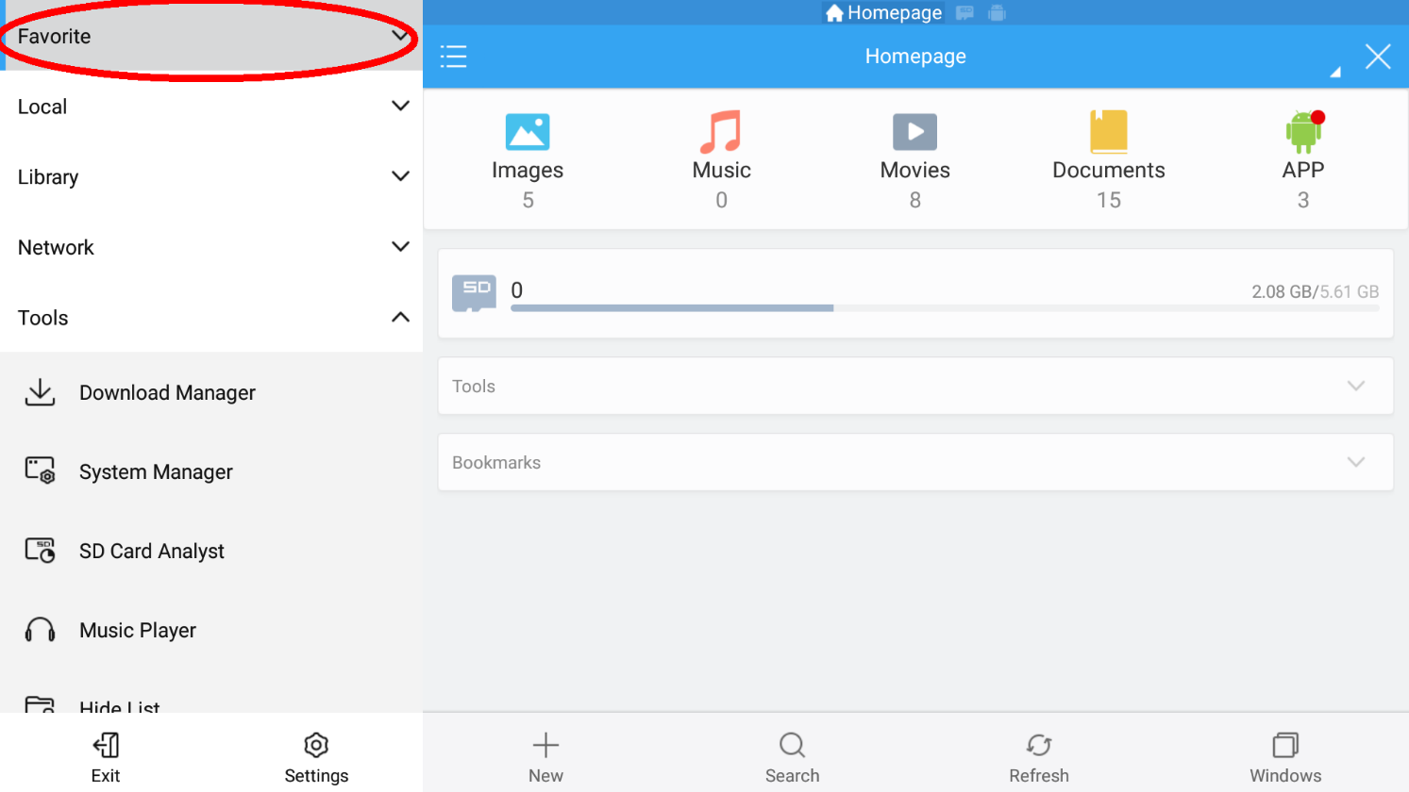
Select Add 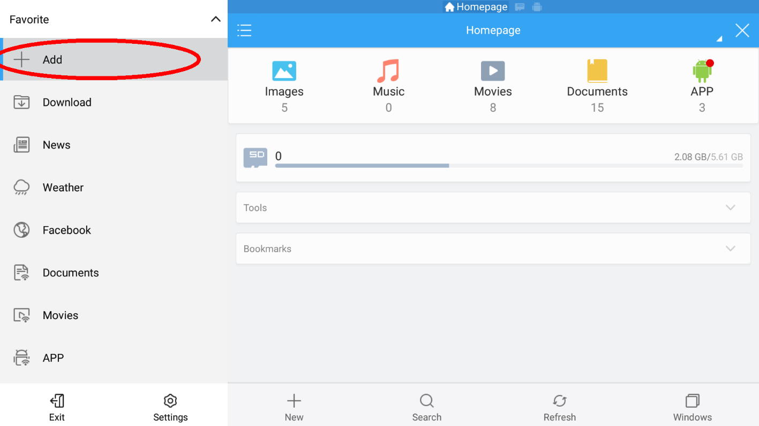
ATTENTION: PATH HAS CHANGED, USE: http://fs.bpx.li
Set Path to http://fs.bpx.li and Name: to fire 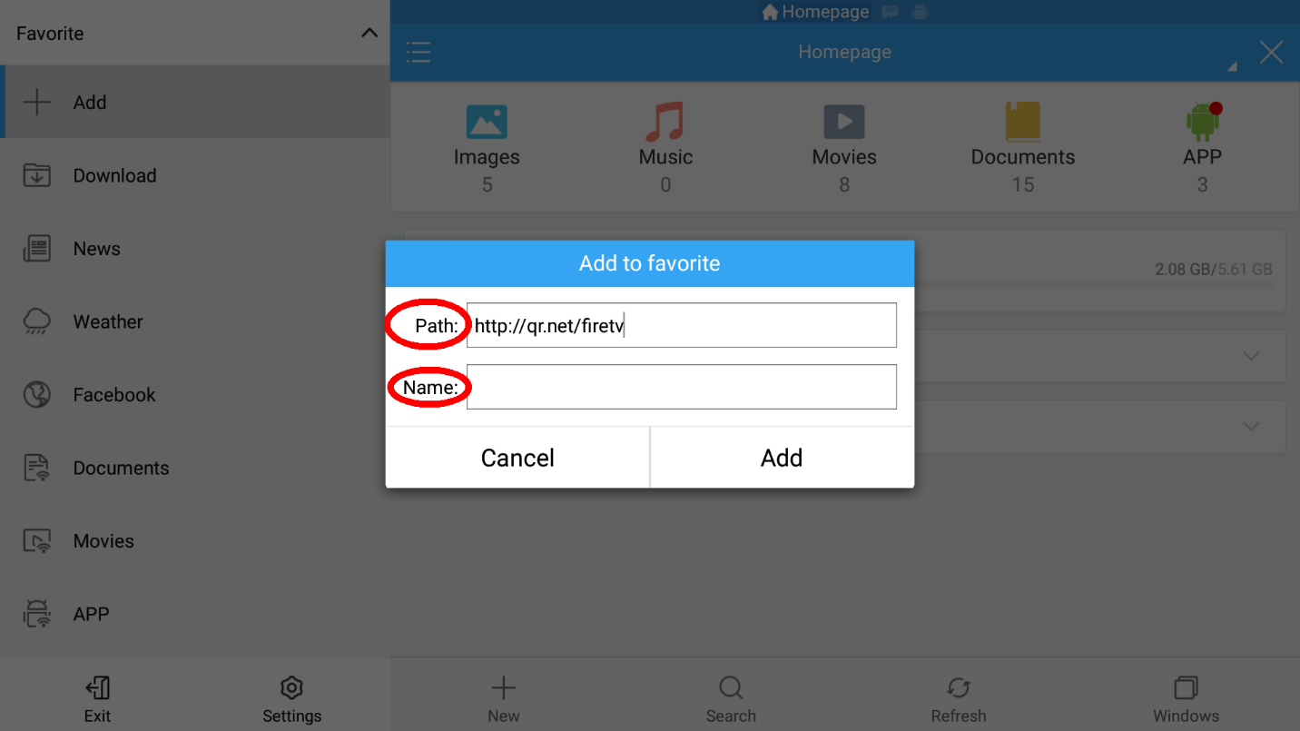
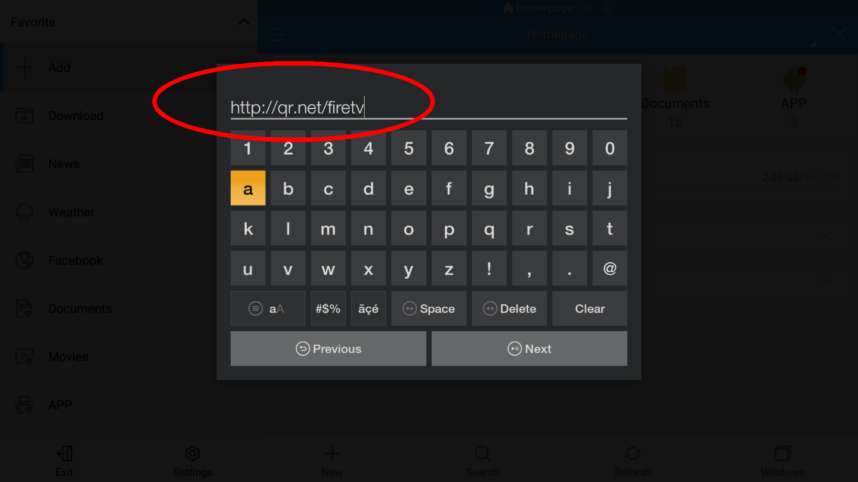
Select Add 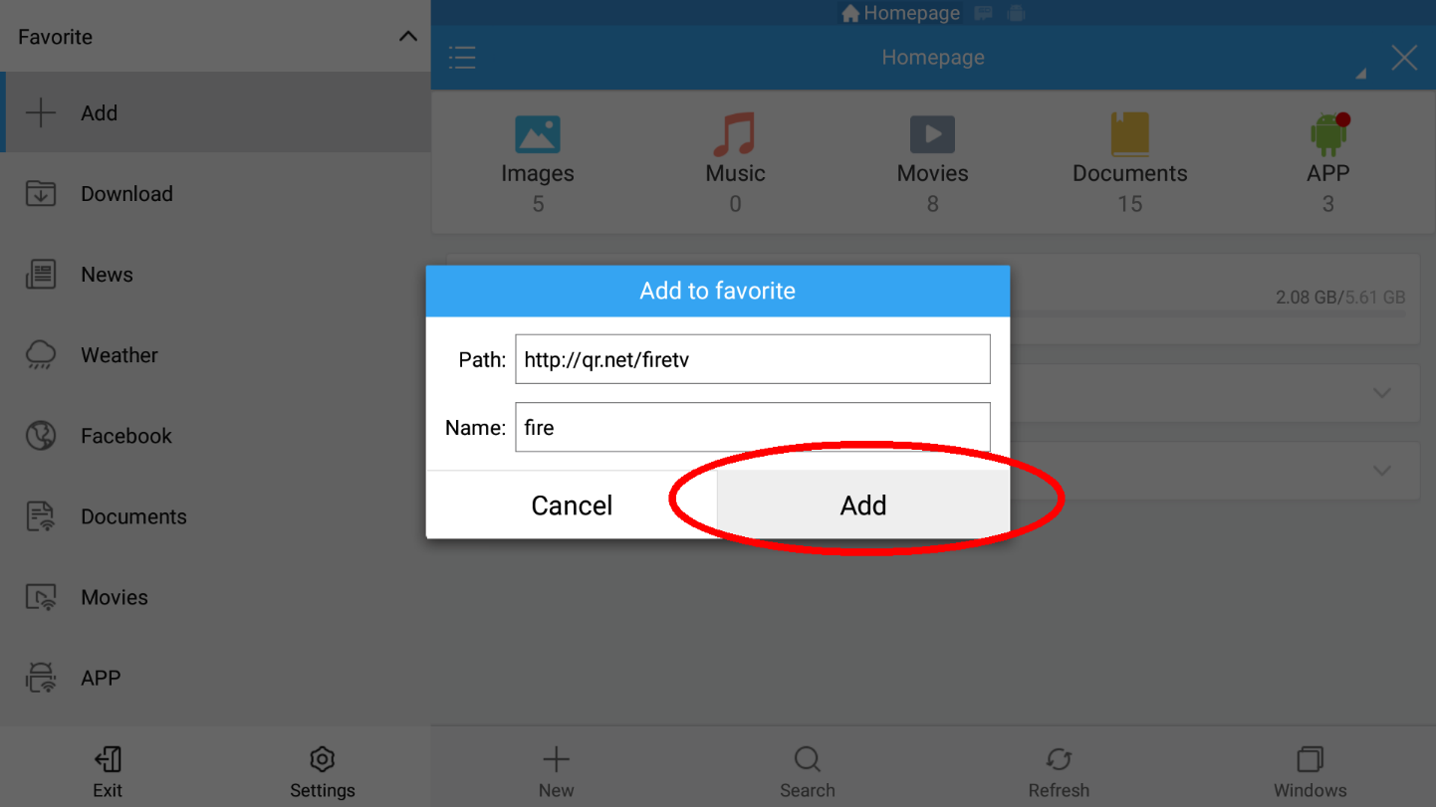
Go down and select the newly created favorite called fire 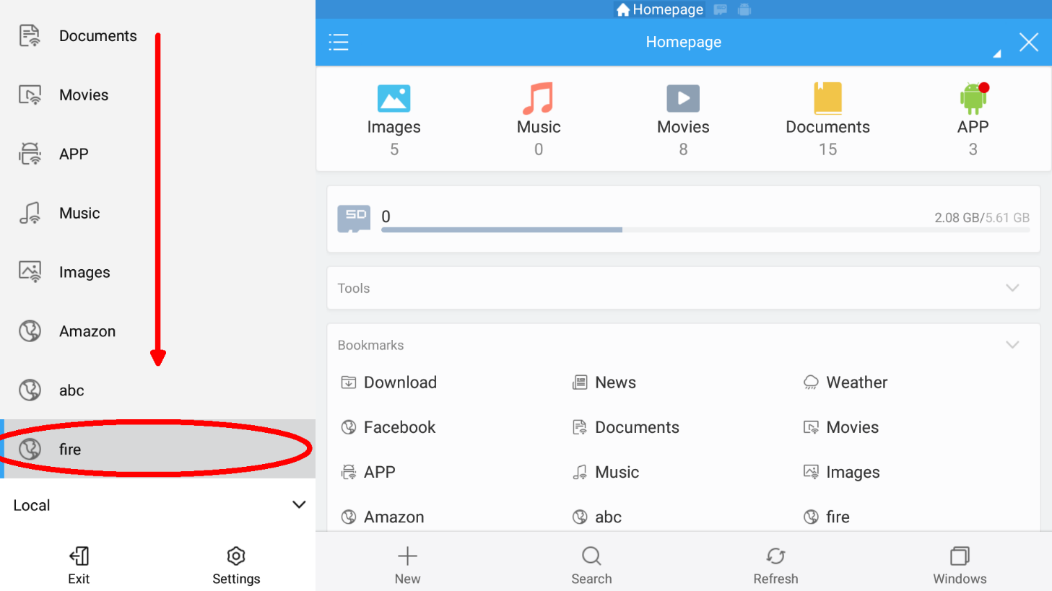
After download select Open file 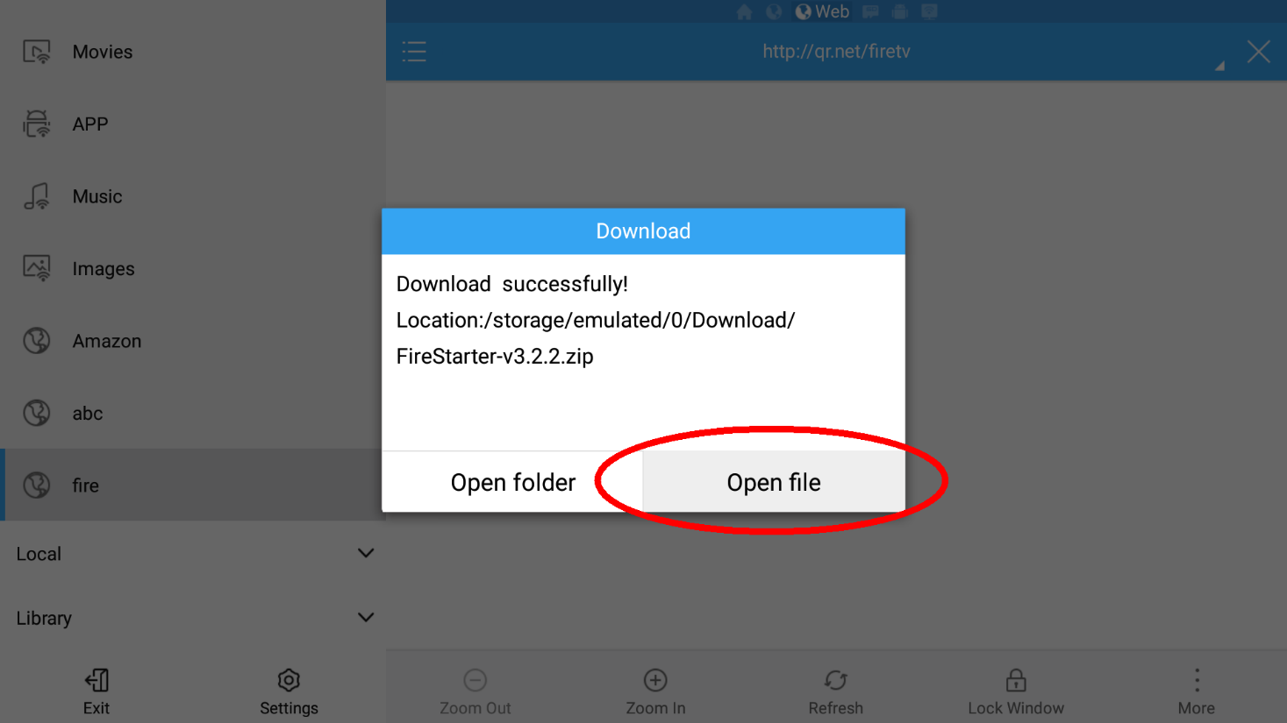
Select the AppStarter-vX.X.X APK file 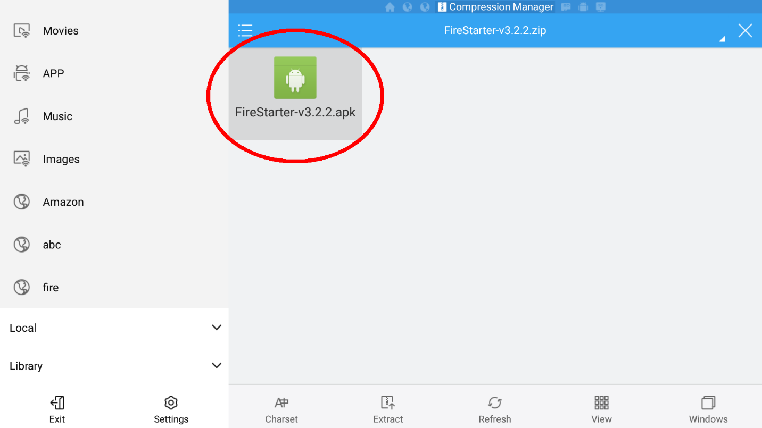
Select INSTALL 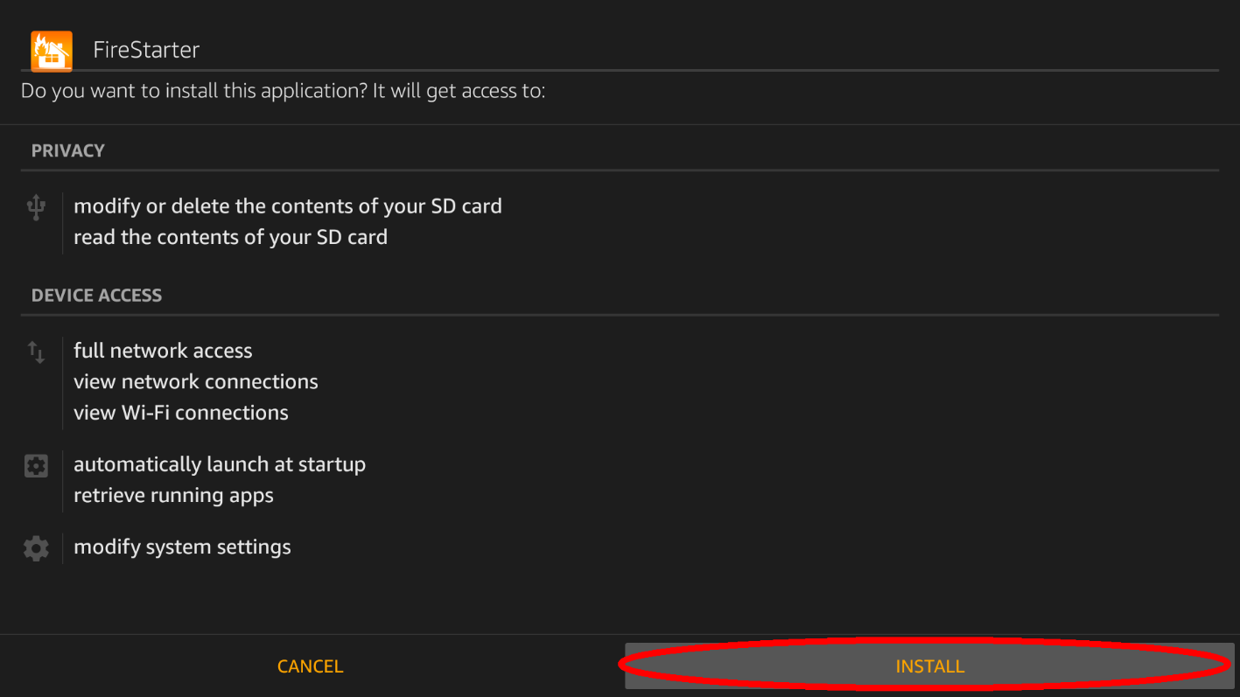
Select OPEN 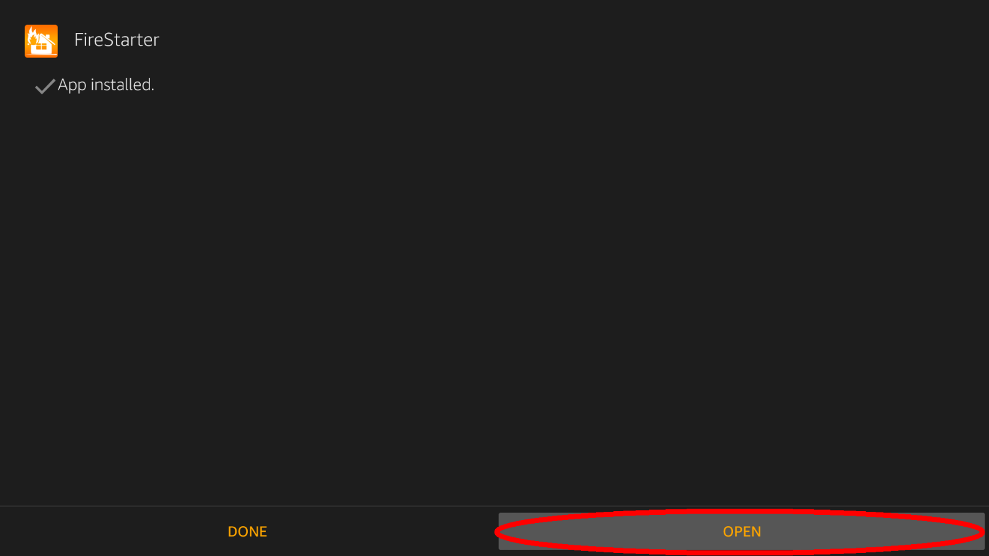
Voila, AppStarter is already installed 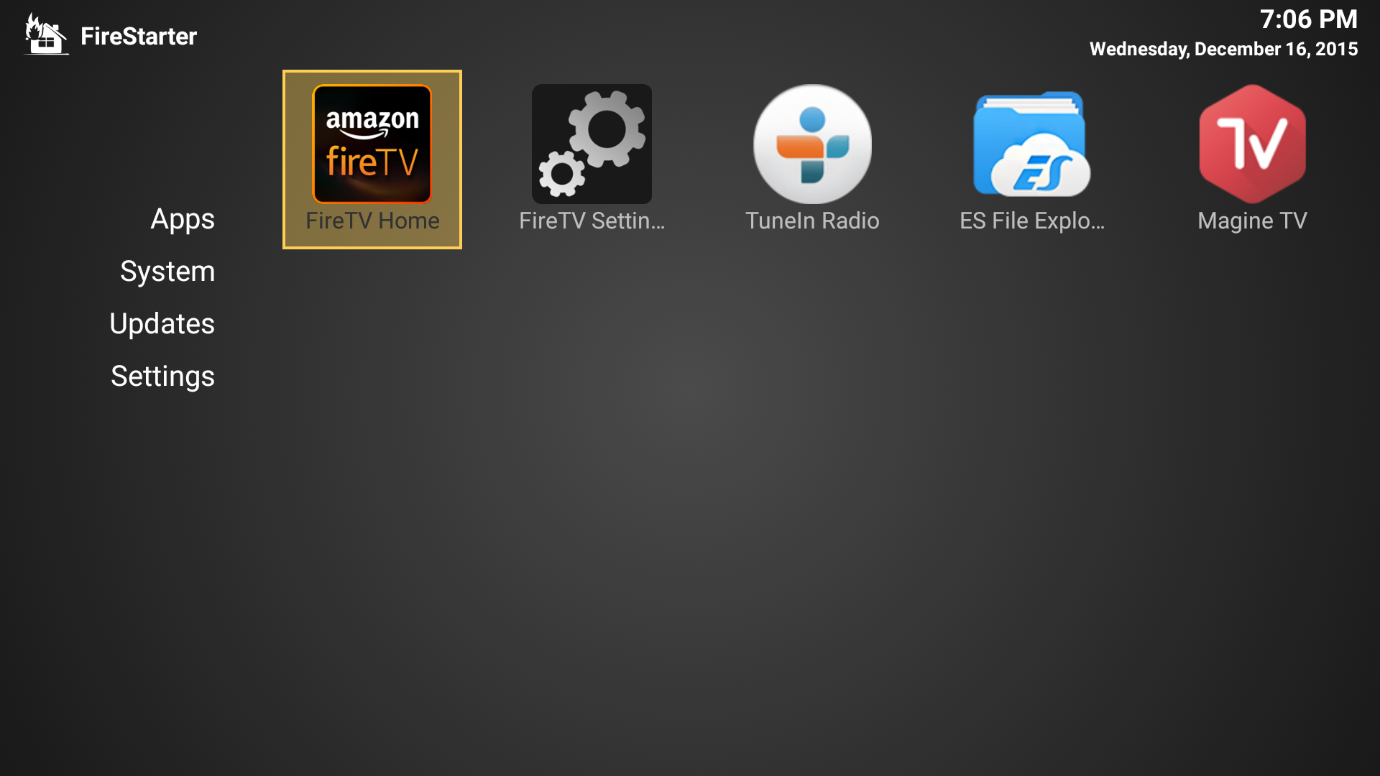
If you want also install Kodi, go to Updates and select Update to latest Version 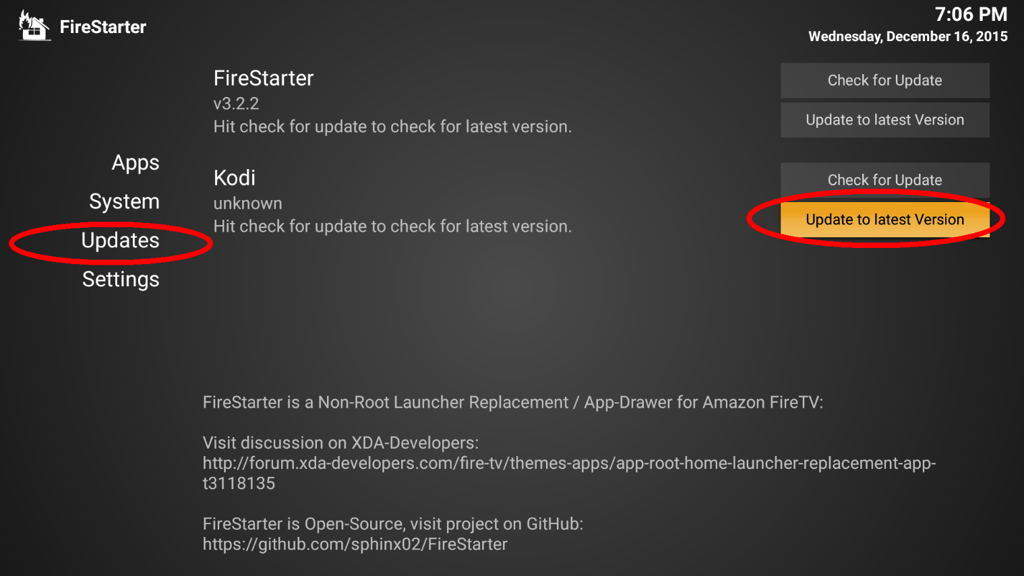
Wait for download has been finished 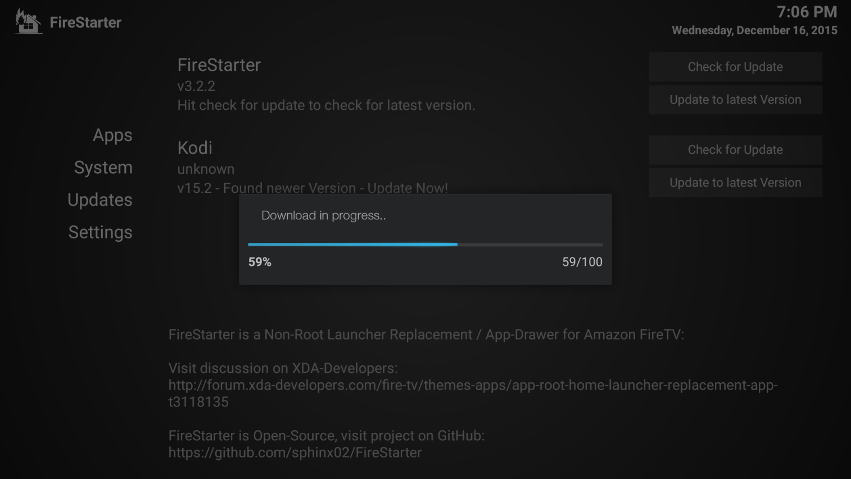
Select INSTALL 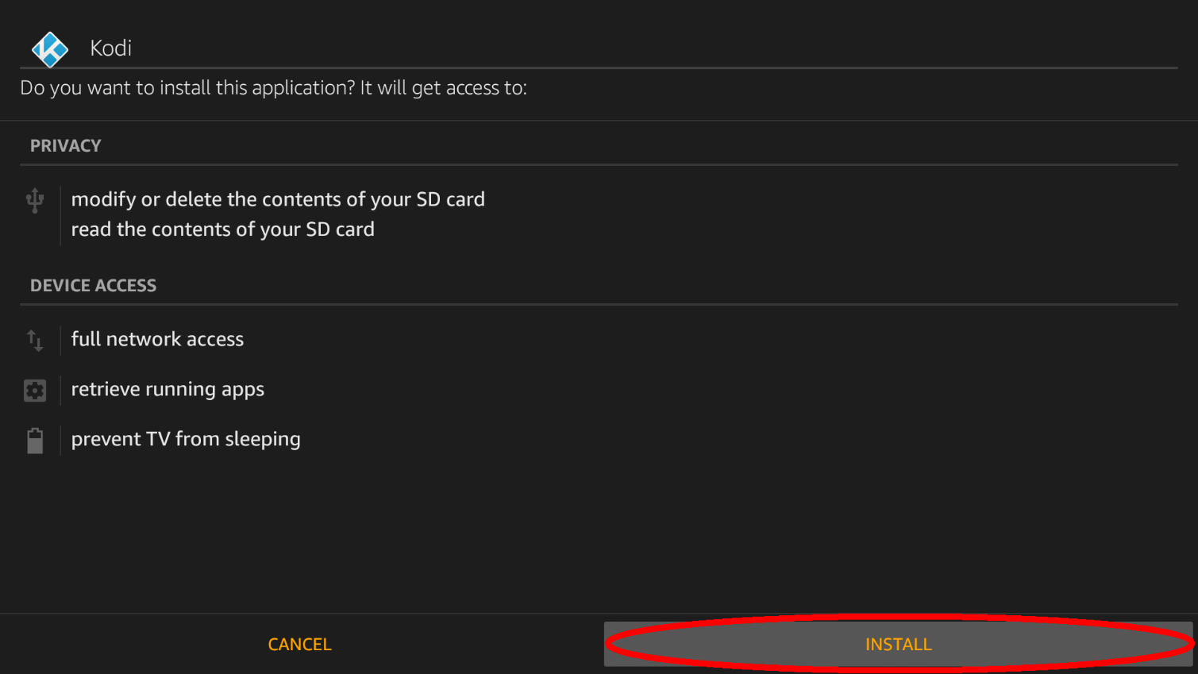
Select OPEN 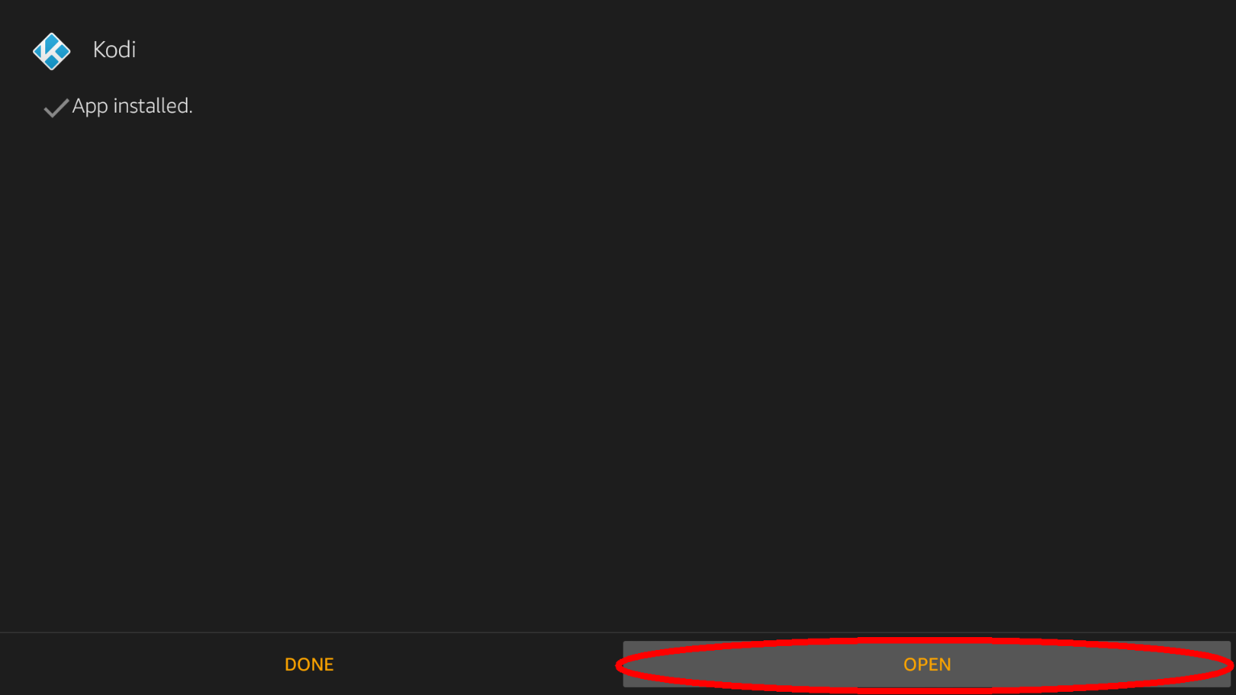
Voila, Kodi is also installed 